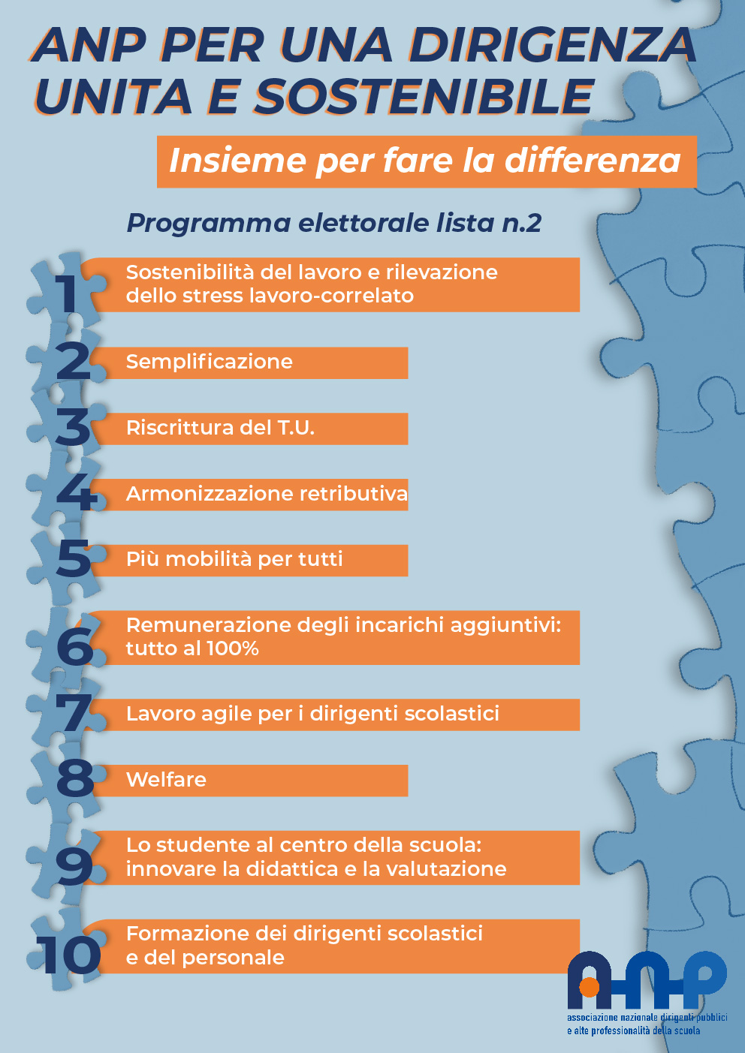

|  |  |
| --- | --- |
| |  | | --- | |  | |

|  |
| --- |
| [https://anp.img.musvc2.net/static/3640/images/1/grafica%20def_aggiornata_.png](https://anp.musvc2.net/e/tr?q=5%3dGcDb%26z%3dX%26x%3dYJfD%26G%3dIdDaMdC%26M%3dvQ4H7_Oaud_ZK_JezZ_TT_Oaud_YPOAT.kF4.F4_JezZ_TTYJTH_Oaud_YPbG_Oaud_YPSG_Oaud_YPY-18q9wL-BbFa-oDsWsG2F-mK4F-6G88-v3-zF3Lo-8xH-4B2-M28-nA6Fq72Wk-M2F43-s-PyK8BxApFv7_6xcr_Fm%26n%3dE9P65F.KoL%26wP%3dAX3o8kJcF%26L7%3dYJTHgDTGXJSJZA%260%3dGBDVsdETobH8FAJbpck6EeHboXA6oeE7FXFUN0kUqXFSrYl4MBl4Mgk4sZF6M9la&mupckp=mupAtu4m8OiX0wt) |

